**2 Introduction to MTRorporation Business**

**2.1 Objectives of Study**

This project aims to:

1. carry out financial analysis of MTR, Mass Transit Railway Corporation, and study the performance of the company in the 4 core businesses of Hong Kong transport operations, Hong Kong station commercial business, Hong Kong property development & other businesses, and Mainland of China and international businesses;
2. study its business strategy and investigate if it has effectively utilized the railway network to transport public to its property development projects / malls and achieve for a mutual benefit in profit making;
3. verify if the management of the company has made use of their resources to generate further income; and
4. evaluate if the company is a good choice of investment.

To fulfill the project requirements, financial statements of the company in the previous years, up to 2014, will be obtained. Various financial ratios and comparison methods will be applied to analyze its performance and value. Findings will be discussed in detail for each of the core business as laid out in the following sections of the report.

**2.2 Background of MTRorporation Company**

MTR is one of the world’s leading railway operators, it has over half of the world’s total busload which reaches 19 hundreds billion. Our report mainly covers the business of HK transport operation, HK property and international consultant business.

MTR has an average of 5.5 million passengers. We take MTR subway in our daily life. Accordingly, all members of the group have strong interest dig into the financial analysis of MTRorporation and evaluate the management pattern lying under the financial data.

**2.2.1 History of MTRorporation**

MTR has quite a long history. It was established in 1975 as the Mass Transit Railway Corporation with a mission to construct and operate, under prudent commercial principles, an urban metro system to help meet Hong Kong's public transport requirements. The sole shareholder was the Hong Kong Government. The Company was re-established as the MTRorporation Limited in June 2000 after the Hong Kong Special Administrative Region Government sold 23% of its issued share capital to private investors in an Initial Public Offering. MTRorporation shares were listed on the Stock Exchange of Hong Kong on 5 October 2000. Another major event happens on 2 December 2007 when the operations of the other Government-owned rail operator, the Kowloon-Canton Railway Corporation, were merged into the MTR, heralding a new era in Hong Kong railway development.

Nowadays, besides bringing convenient and efficient rails to Hong Kong residents, MTR brought new growth opportunities to the MTRorporation's businesses in and outside of Hong Kong. The Corporation also operates airport express service. It is a high-speed link providing airport of Hong Kong with city’s major exhibition and conference center.

**2.2.2 Major Business**

MTRorporation covers business of development of residential and commercial properties, property leasing and management, advertising, telecommunication services and international consultancy services.

1. Hong Kong Transport Operations

MTR is regarded as one of the world’s leading railways for safety, reliability, customer service and cost efficiency. The MTR network comprises nine railway lines serving Hong Kong Island, Kowloon and the New Territories. In addition, a Light Rail network serves the local communities of Tuen Mun and Yuen Long in the New Territories while a fleet of buses provide convenient feeder services. MTR trains run about 19 hours a day, 7 days a week, from early morning (5:30 am - 6:00 am) to 1:00 am the next morning. The territory-wide 9-line commuter network has expanded its number of interchange stations to 19 in order to provide convenient transfer points between our separate lines:

* Kwun Tong Line (running between Yau Ma Tei and Tiu Keng Leng)
* Tsuen Wan Line (running between Tsuen Wan and Central)
* Island Line (running between Kennedy Town and Chai Wan)
* Tseung Kwan O Line (running between Po Lam/LOHAS Park and North Point)
* Tung Chung Line (running between Tung Chung and Hong Kong)
* Airport Express (running between AsiaWorld-Expo and Hong Kong)
* Disneyland Resort Line (running between Sunny Bay and Disneyland Resort)
* East Rail Line (running between Hung Hom and Lo Wu/Lok Ma Chau)
* West Rail Line (running between Hung Hom and Tuen Mun)
* Ma On Shan Line (running between Tai Wai and Wu Kai Sha)

|  |  |
| --- | --- |
| Service category | Details |
| Domestic services | 9 main customer lines as shown above |
| Cross boundary service | Service running to/from Hong Kong and Shenzhen via Lo Wu or Lok Ma Chau on the East Rail Line |
| Airport express | Direct service linking Hong Kong International Airport and Hong Kong Station in the Central business hub |
| Light rail and bus | Light Rail network in northwestern New Territories and feeder bus services to/from MTR stations and New Territories |
| Intercity | Three through train routes to/from cities in the Mainland of China, namely Beijing, Shanghai and Guangdong |

Table: Hong Kong Rail Way Network

1. Hong Kong Station Commercial Businesses

In order to make the most use of railway assets, MTR operates related businesses such as leasing station retail place, advertising in trains and stations, and fixed and mobile telecommunication services. MTR offers wide range of retail outlets in all stations.

The many choices include food and beverage, health and beauty outlets, bakeries, convenience stores such as 711, gifts, accessories and drinks. As we can discover, the vending machines are also part of the MTR business. MTR offers duty free shops to attract the visitors from mainland china. There are also quite a large range of exhibition sites located in the MTR stations. Currently, there are a total of 51 sites at stations on the Urban Line and Airport Express and a further 13 sites at stations along the East Rail Line.

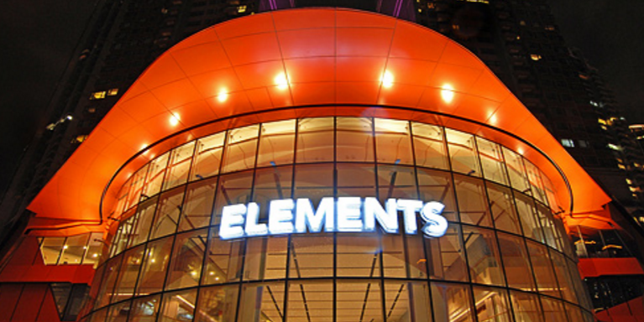

*ELEMENTS shopping center*

Until now, MTR owns 1 luxury mall, 3 regional malls and 8 neighborhood malls. ELMENTS, as the one of the biggest shopping centers in Hong Kong, offers more than one million square feet of pure shopping bliss subtly themed after the five Chinese elements. The mall brings together some of the world's most sought-after brands and services, many of which are either new to Hong Kong or have their flagship stores here. Dining is also a major attraction at ELEMENTS, with big names in both Oriental and Western cuisine.

1. Hong Kong Property Development

MTRorporates with other property developers to build properties above or near stations. The investment properties cover 13 shopping malls and 41006 square meters of office space. The corporation also manages residential properties, office space and commercial space. At the end of 2014, they owned 91434 residential units and 763018 square meters of commercial and office space under management.

MTR Property holds the mission of understanding customers as well as market to provide products and services beyond their expectations to enhance life. MTR makes use of the opportunity to pursue sustainable profit growth and market expansion in their development, investment and managed properties.

1. Mainland and International Businesses

From its starting base in Hong Kong, the Corporation has expanded into the Mainland of China and taken on a range of railway-related projects and operations internationally. In the Mainland of China, the Corporation now operates Beijing Metro Line 4 and Line 14, Shenzhen Metro Line 4th and Hangzhou Metro Line 1.

The Corporation also operates and manages London Overground in the United Kingdom, Melbourne’s Metropolitan Rail Service in Australia, Stockholm Metro and intercity service between Stockholm and Gothenburg in Sweden. The Corporation was awarded the cross-rail Train Operating Concession in the United Kingdom in July 2014, and in September 2014 the Northwest Rapid Transit Consortium, of which the Corporation is a shareholder, was awarded the Operations, Trains and Systems (OTS) Public-Private Partnership (PPP) contract for the Sydney Metro North West project in Sydney. In February 2015, Beijing MTRorporation Limited, of which we are a shareholder, initialized the Concession Agreement for Beijing Metro Line 16 and it will participate in the investment, operations and maintenance of this new line under PPP.

Internationally, the Corporation operates and manages London Overground, and TFL Rail, the first phase of the future Cross-rail service, in the United Kingdom, Melbourne Metro in Australia, Stockholm Metro and MTR Express, an intercity railway between Stockholm and Gothenburg in Sweden. In September 2014 the Northwest Rapid Transit Consortium, of which the Corporation is a shareholder, was awarded the Operations, Trains and Systems Public-Private Partnership contract for the Sydney Metro Northwest project in Australia. In November 2015, Beijing MTRorporation Limited, of which MTR is a shareholder, signed the Concession Agreement for Beijing Metro Line 16, a Public-Private Partnership project and it will participate in the investment, operations and maintenance of this new line. In December 2015, MTR Nordic, a wholly owned subsidiary of the Corporation, was awarded the concession to operate and manage the Stockholm Commuter Rails System. On top of that, the scope of the Corporation's consultancy business also widened to cover cities across Asia, Australia and the Middle East.

Based on the successful "rail plus property" development model in Hong Kong, the Corporation has expanded into the Mainland of China with property businesses in Beijing, Shenzhen and Tianjin. The pre-sale of "Tiara", the first MTR property development project in the Mainland of China, was well received.

MTRorporation offers worldwide consultancy and contracting services on railway planning, design management, system integration & assurance, project management, construction management, railway operation & maintenance and non-fare revenue business.

The Corporation has provided services to a number of railway and metro companies, government authorities and rail system suppliers in Australia, the Mainland of China, India, the Middle East, Latin America and Southeast Asia. Locally in Hong Kong, it also provides operation and maintenance services for the Automated People Mover (APM) at Hong Kong International Airport. The APM is currently being expanded to match the growth in air travel.

**2.2.3 Financial Overview**

MTRorporation operates an integrated railway network in Hong Kong comprising the MTR-built and owned metro railway lines and since 2 December 2007, the regional rail lines of the Kowloon-Canton Railway Corporation (KCRC) under a service concession arrangement. MTR is listed on the Stock Exchange of Hong Kong with a market capitalization of HK$185 billion as of 31 December 2014.

The Corporation finances its operating and capital requirements through a variety of means including debt and equity issuance, income from railway and related operations, and profits from property development, investment and management.

The Corporation was the first Hong Kong corporate entity to obtain internationally recognized credit ratings and has since maintained investment grade ratings on par with the Hong Kong Special Administrative Region Government. Currently, its foreign currency debts are rated AAA, Aa1 and AA+ respectively by Standard & Poor’s, Moody’s and Rating and Investment Information Inc. of Japan.

**5.0 Financial Analysis & Comparison**

**5.1 Overview Summary of Financial Statements**

This section gives an overview analysis of the key financial data. Further performance details and comparison of each core business will be covered in Sections 5.2 to 5.5. Data of up to 10 years may be presented but major focus will be put in the last 5 years from 2010 to 2014 in the analysis.

**5.1.1 Ten-Year Key Statistics**

| in HK$ million | 2014 | 2013 | 2012 | 2011 | 2010 | 2009 | 2008 | 2007 | 2006 | 2005 |
| --- | --- | --- | --- | --- | --- | --- | --- | --- | --- | --- |
| **Consolidated Profit and Loss Account** |  |  |  |  |  |  |  |  |  |  |
| Turnover | 40,156 | 38,707 | 35,739 | 33,423 | 29,518 | 18,797 | 17,628 | 10,690 | 9,541 | 9,153 |
| Operating profit before depreciation, amortisation and variable annual payment | 19,639 | 15,795 | 16,133 | 17,058 | 14,951 | 13,069 | 14,009 | 14,229 | 11,032 | 11,259 |
| Depreciation and amortisation | 3,485 | 3,372 | 3,208 | 3,206 | 3,120 | 2,992 | 2,944 | 2,752 | 2,688 | 2,695 |
| Interest and finance charges | 545 | 732 | 879 | 921 | 1,237 | 1,504 | 1,998 | 1,316 | 1,398 | 1,361 |
| Investment property revalation gain/loss | 4,035 | 4,425 | 3,757 | 5,088 | 4,074 | 2,798 | -146 | 8,011 | 2,178 | 2,800 |
| Profit for the year | 15,797 | 13,208 | 13,514 | 15,688 | 12,844 | 10,101 | 8,035 | 16,584 | 8,139 | 8,953 |
| Profit attributable to equity shareholders arising from underlying businesses | 11,571 | 8,600 | 9,618 | 10,468 | 8,657 | 7,300 | 8,185 | 8,571 | 5,962 | 6,140 |
| Dividend proposed and declared | 6,116 | 5,335 | 4,575 | 4,396 | 3,405 | 2,977 | 2,715 | 2,522 | 2,328 | 2,299 |
| Earnings per share(HK$) | 2.69 | 2.25 | 2.31 | 2.69 | 2.21 | 1.77 | 1.43 | 2.98 | 1.48 | 1.65 |
| **Consolidated Balance Sheet(HK million $)** |  |  |  |  |  |  |  |  |  |  |
| Total assets | 227,152 | 215,823 | 206,687 | 197,684 | 181,660 | 176,492 | 159,345 | 155,668 | 120,421 | 113,666 |
| Loans, other obligations and bank overdrafts | 20,507 | 24,511 | 23,577 | 23,168 | 21,057 | 23,868 | 31,289 | 34,050 | 28,152 | 28,264 |
| Obligations under service concession | 10,614 | 10,658 | 10,690 | 10,724 | 10,749 | 10,625 | 10,656 | 10,685 | - | - |
| Deferred income | 765 | 623 | 488 | 403 | 605 | 167 | 156 | 515 | 1,682 | 3,584 |
| Total equity attributable to equity shareholders | 163,325 | 152,577 | 142,904 | 131,907 | 121,914 | 110,479 | 101,431 | 94,889 | 79,242 | 71,969 |
| **Financial Ratios(%)** |  |  |  |  |  |  |  |  |  |  |
| Operating margin(%) | 38.4 | 37.2 | 36.1 | 36.3 | 37 | 50.6 | 53 | 55.4 | 54.7 | 55.9 |
| Operating margin (excluding Mainland of China and international subsidiaries)(%) | 53.1 | 53.4 | 53.6 | 55.6 | 55.1 | 53.8 | 53.2 | 55.9 | 55.3 | 55.9 |
| Net debt-to-equity ratio (%) | 7.6 | 11.8 | 11 | 11.6 | 12.3 | 24.9 | 40.6 | 46.5 | 35.1 | 38.8 |
| Interest cover (times) | 15.2 | 11.5 | 13 | 14.5 | 10.5 | 7.1 | 6 | 9 | 6.7 | 7.6 |

*Table 1: Ten-year key statistics [1]*

The ten-year statistics, which is shown in *Table 1*, co-relate to the major events of MTR in the past. Turnover grew steadily over the last 10 years with a significant rise in 2008 due to the merging with Kowloon-Canton Railway Corporation (KCRC) which brought over 60% of increase in revenue. The figure kept on rising in subsequent years with new extension lines coming into service (e.g. West Island Line), improving of operation efficiency after merging, and good performance of its properties & station commercial businesses.

Meanwhile, an increase in loans was observed when the rail merger plan started in 2007. A drop in profit was, however, recorded in 2008 which was caused by the bad performance of property sale under the impact of global financial turmoil. That was also reflected in the negative figure of investment property revaluation in the same year.

Over the next few years, with a series of optimistic reasons (including reduction of interest rate in the global market, cash surplus from operating activities, and receipt of government funding support), MTR was able to decrease the net debt-to-equity ratio from over 40% in 2008 to under 10% in 2014.

In 2010, a new railway subsidiary in Mainland of China commenced operations. However, due to the lower than expected performance of Shenzhen Metro (SZMTR) and Mass Transit Railway Stockholm (MTRS), the operating margin dropped from 50.6% in 2009 down to 37% in 2010. Excluding the Mainland of China and international subsidiaries, MTR's operating margin remained steady at above 50%.

Amount of total assets increased steadily since 2009 mainly due to investment property revaluation gains under the uptrend of property market, capitalisation of construction costs of various railway extension projects (e.g. Shenzhen Line 4, West Island Line, South Island Line (East), Kwun Tong Line etc.), and property development in progress.

The interest cover remained at the range of 15.2 to 10.5 in the last 5 years. It shows that interest expense is only a small portion of earnings before interest & taxes. Together with a low net debt-to-equity ratio, MTR can take further loan for business expansion to generate further income without much trouble in meeting interest payment.

**5.1.2 Consolidated Balance Sheet**

| in HK$ million | At 31 December 2014 | At 31 December 2013 | At 31 December 2012 | At 31 December 2011 | At 31 December 2010 |
| --- | --- | --- | --- | --- | --- |
| **Assets** |  |  |  |  |  |
| Fixed assets |  |  |  |  |  |
| – Investment properties | 65,679 | 61,285 | 55,314 | 51,453 | 45,314 |
| – Other property, plant and equipment | 78,279 | 76,277 | 76,088 | 76,687 | 77,276 |
| – Service concession assets | 26,698 | 25,594 | 24,492 | 23,928 | 21,467 |
|  | 170,656 | 163,156 | 155,894 | 152,068 | 144,057 |
| Property management rights | 30 | 31 | 31 | 31 | 31 |
| Railway construction in progress | 16,229 | 11,548 | 7,458 | 3,566 | N/A |
| Property development in progress | 7,490 | 11,233 | 10,430 | 11,964 | 9,128 |
| Deferred expenditure | 64 | 4 | 15 | 14 | 1,079 |
| Interests in non-controlled subsidiaries | N/A | N/A | 433 | 579 | 541 |
| Interests in associates | 5,797 | 5,277 | 3,825 | 948 | 836 |
| Deferred tax assets | 50 | 29 | 21 | 24 | 9 |
| Investments in securities | 527 | 472 | 393 | 2,974 | 3,912 |
| Properties held for sale | 1,076 | 1,105 | 3,016 | 3,757 | 1,936 |
| Derivative financial assets | 105 | 115 | 256 | 344 | 375 |
| Stores and spares | 1,365 | 1,281 | 1,220 | 1,135 | 1,061 |
| Debtors, deposits and payments in advance | 3,797 | 3,621 | 4,474 | 3,964 | 3,061 |
| Loan to a property developer | N/A | N/A | N/A | N/A | 1,975 |
| Amounts due from related parties | 1,073 | 654 | 785 | 402 | 330 |
| Cash, bank balances and deposits | 18,893 | 17,297 | 18,664 | 16,100 | 13,334 |
|  | 227,152 | 215,823 | 206,915 | 197,870 | 181,665 |
| **Liabilities** |  |  |  |  |  |
| Bank overdrafts | 46 | 47 | 55 | N/A | 16 |
| Short-term loans | 500 | N/A | 300 | N/A | 300 |
| Creditors and accrued charges | 16,421 | 13,793 | 15,119 | 16,402 | 15,491 |
| Current Taxation | 996 | 349 | 406 | 597 | 1,018 |
| Contract retentions | 1,094 | 986 | 948 | 643 | 404 |
| Amounts due to related parties | 1,607 | 1,388 | 1,061 | 1,481 | 892 |
| Loans and other obligations | 19,961 | 24,464 | 23,222 | 23,168 | 20,741 |
| Obligations under service concession | 10,614 | 10,658 | 10,690 | 10,724 | 10,749 |
| Derivative financial liabilities | 565 | 389 | 132 | 151 | 148 |
| Loan from holders of non-controlling interests | 124 | 135 | 157 | 154 | 154 |
| Deferred income | 765 | 623 | 488 | 403 | 605 |
| Deferred tax liabilities | 10,977 | 10,289 | 9,857 | 9,498 | 13,854 |
|  | 63,670 | 63,121 | 62,435 | 63,221 | 64,372 |
| **Net assets** | 163,482 | 152,702 | 144,480 | 134,649 | 117,293 |
|  |  |  |  |  |  |
| **Capital and reserves** |  |  |  |  |  |
| Share capital and other statutory capital reserves | 45,280 | 44,442 | 44,281 | 44,062 | 43,734 |
| Other reserves | 118,045 | 108,115 | 99,992 | 90,401 | 73,416 |
| **Total equity attributable to equity shareholders of the Company** | 163,325 | 152,557 | 144,273 | 134,463 | 117,150 |
| **Non-controlling interests** | 157 | 145 | 207 | 186 | 143 |
| **Total equity** | 163,482 | 152,702 | 144,480 | 134,649 | 117,293 |

*Note: The items highlighted in pale green are assumed to be "current" in nature according to the limited amount of information provided.*

*Table 2: Consolidated Balance Sheet for the last 5 years [1]*

*Table 2* shows the breakdown items of assets, liabilities, and equity. As reflected from the figures, the total liabilities of MTR over the past 5 years remained stable at the range of $63 to $64 billion. Assets grew steadily with major contributions from gain in revaluation of investment properties & service concession assets, progress of railway extension projects, and rising amount of cash holding. Capital of the business is mainly allocated in fixed assets including investment properties, other property, plant & equipment, and service concession assets. MTR demonstrate a very strong overall financial position with reserves rising solidly year from year. It makes good use of profits & government funding in expansion to obtain further earnings.

|  | 2014 | 2013 | 2012 | 2011 | 2010 |
| --- | --- | --- | --- | --- | --- |
| Current Assets (in HK$ million) | 26,836 | 24,545 | 28,808 | 28,676 | 25,984 |
| Current Liabilities (in HK$ million) | 20,135 | 15,966 | 17,073 | 18,631 | 17,865 |
| Working Capital (in HK$ million) | 6,701 | 8,579 | 11,735 | 10,045 | 8,119 |
| Current Ratio | 1.33 | 1.54 | 1.69 | 1.54 | 1.45 |
| Quick Ratio | 1.21 | 1.39 | 1.44 | 1.28 | 1.29 |
| Debt Ratio | 0.28 | 0.29 | 0.30 | 0.32 | 0.35 |

*Table 3: Analysis on financial status for the last 5 years*

$$Working Captial=Current Assets-Current Liabilities$$

$$Current Raito=\frac{Current Assets}{Current Liabilities}$$

$$Qucik Raito=\frac{Current Assets-Inventories}{Current Liabilities}$$

$$Debt Raito=\frac{Total Debt}{Total Assets}$$

To further look into the liquidity status of MTR, a number of ratios are calculated and presented in *Table 3*. The company was able to maintain a healthy level of working capital over the past. The current ratio stayed at the range of 1.33 - 1.69 while the debt ratio dropped from 0.35 in 2010 to 0.28 in 2014. That means MTR has sufficient current asset to meet its current liability with some buffer and debt is only accountable for just around 28 - 35% of its total asset. Although there is a decreasing trend of working capital in the last couple of years, with a number of new extension lines completing in the next few years, revenue from railway operation and station commercial business will rise brining into additional cash to the business. In the event of extreme case, the quick ratio of above 1 indicates that MTR is able to pay off its short-term creditors without much trouble. Overall, MTR manages a good use of financial leverage without over-exploiting its position causing any liquidity problem.

**5.1.3 Consolidated Profit and Loss**

| For the year ended 31 December in HK$ million | 2014 | 2013 | 2012 | 2011 | 2010 |
| --- | --- | --- | --- | --- | --- |
| Revenue from Hong Kong transport operations | 16,223 | 15,166 | 14,523 | 13,509 | 12,635 |
| Revenue from Hong Kong station commercial businesses | 4,963 | 4,588 | 3,680 | 3,422 | 2,853 |
| Revenue from Hong Kong property rental and management businesses | 4,190 | 3,778 | 3,401 | 3,083 | 2,961 |
| Revenue from Mainland of China and international subsidiaries | 12,627 | 13,246 | 12,786 | 12,411 | 10,144 |
| Revenue from other businesses | 2,153 | 1,929 | 1,349 | 998 | 925 |
|  | 40,156 | 38,707 | 35,739 | 33,423 | 29,518 |
| Expenses relating to Hong Kong transport operations |  |  |  |  |  |
| – Staff costs and related expenses | -4,450 | -4,198 | -3,879 | -3,673 | -3,398 |
| – Energy and utilities | -1,409 | -1,293 | -1,200 | -1,110 | -1,067 |
| – Operational rent and rates | -269 | -259 | -234 | -199 | -184 |
| – Stores and spares consumed | -540 | -514 | -477 | -466 | -421 |
| – Maintenance and related works | -1,361 | -1,177 | -1,112 | -1,048 | -912 |
| – Railway support services | -253 | -246 | -210 | -206 | -207 |
| – General and administration expenses | -640 | -515 | -479 | -429 | -379 |
| – Other expenses | -314 | -247 | -238 | -223 | -253 |
|  | -9,236 | -8,449 | -7,829 | -7,354 | -6,821 |
| Expenses relating to Hong Kong station commercial businesses | -515 | -464 | -397 | -358 | -294 |
| Expenses relating to Hong Kong property rental and management businesses | -747 | -673 | -627 | -587 | -654 |
| Expenses relating to Mainland of China and international subsidiaries | -11,821 | -12,455 | -12,184 | -11,964 | -9,865 |
| Expenses relating to other businesses | -1,960 | -1,781 | -1,296 | -913 | -751 |
| Project study and business development expenses | -454 | -486 | -323 | -123 | -216 |
| **Operating expenses before depreciation, amortisation and variable annual payment** | -24,733 | -24,308 | -22,656 | -21,299 | -18,601 |
|  |  |  |  |  |  |
| **Operating profit before Hong Kong property development, depreciation, amortisation and variable annual payment** |  |  |  |  |  |
| – Arising from recurrent businesses | 15,478 | 14,399 | 13,083 | 12,124 | 10,917 |
| – Arising from Mainland of China property development | -55 | N/A |
|  | 15,423 | 14,399 | 13,083 | 12,124 | 10,917 |
| Profit on Hong Kong property development | 4,216 | 1,396 | 3,238 | 4,934 | 4,034 |
| **Operating profit before depreciation, amortisation and variable annual payment** | 19,639 | 15,795 | 16,321 | 17,058 | 14,951 |
| Depreciation and amortisation | -3,485 | -3,372 | -3,208 | -3,206 | -3,120 |
| Variable annual payment | -1,472 | -1,247 | -883 | -647 | -45 |
| **Operating profit before interest and finance charges** | 14,682 | 11,176 | 12,230 | 13,205 | 11,786 |
| Interest and finance charges | -545 | -732 | -879 | -921 | -1,237 |
| Investment property revaluation | 4,035 | 4,425 | 3,757 | 5,088 | 4,074 |
| Share of profit or loss of associates | 121 | 158 | 456 | 297 | 139 |
| **Profit before taxation** | 18,293 | 15,027 | 15,564 | 17,669 | 14,762 |
| Income tax | -2,496 | -1,819 | -1,893 | -1,981 | -2,590 |
| **Profit for the year** | 15,797 | 13,208 | 13,671 | 15,688 | 12,172 |
|  |  |  |  |  |  |
| **Attributable to:** |  |  |  |  |  |
| – Equity shareholders of the Company | 15,606 | 13,025 | 13,532 | 15,556 | 12,059 |
| – Non-controlling interests | 191 | 183 | 139 | 132 | 113 |
| **Profit for the year** | 15,797 | 13,208 | 13,671 | 15,688 | 12,172 |
|  |  |  |  |  |  |
| **Profit for the year attributable to equity shareholders of the Company:** |  |  |  |  |  |
| – Arising from underlying businesses before property development | 8,024 | 7,437 | 7,071 | 6,243 | 5,397 |
| – Arising from property development | 3,547 | 1,163 | 2,704 | 4,225 | 3,260 |
| – Arising from underlying businesses | 11,571 | 8,600 | 9,775 | 10,468 | 8,657 |
| – Arising from investment property revaluation | 4,035 | 4,425 | 3,757 | 5,088 | 3,402 |
|  | 15,606 | 13,025 | 13,532 | 15,556 | 12,059 |

*Table 4: Consolidated profit and loss account for the last 5 years [1]*

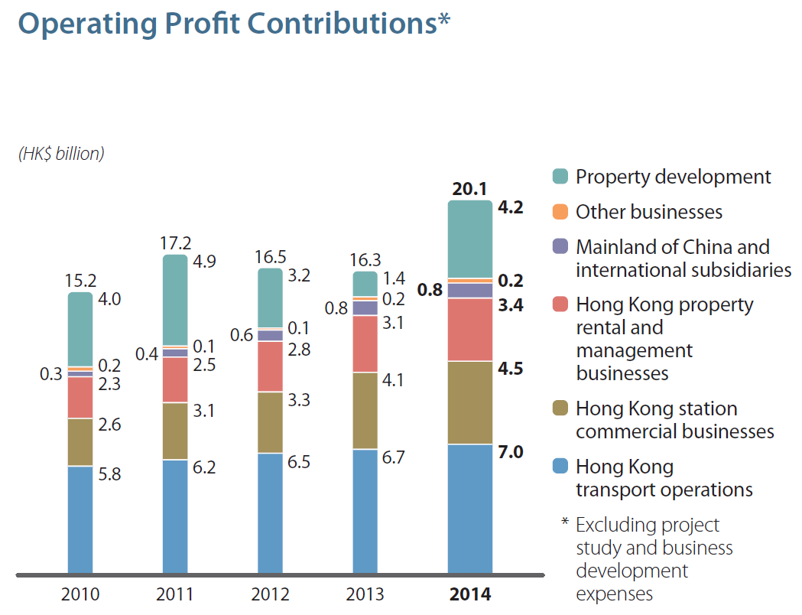

*Figure 1: Operating profit contributions with expenses in project study and business development excluded [1]*

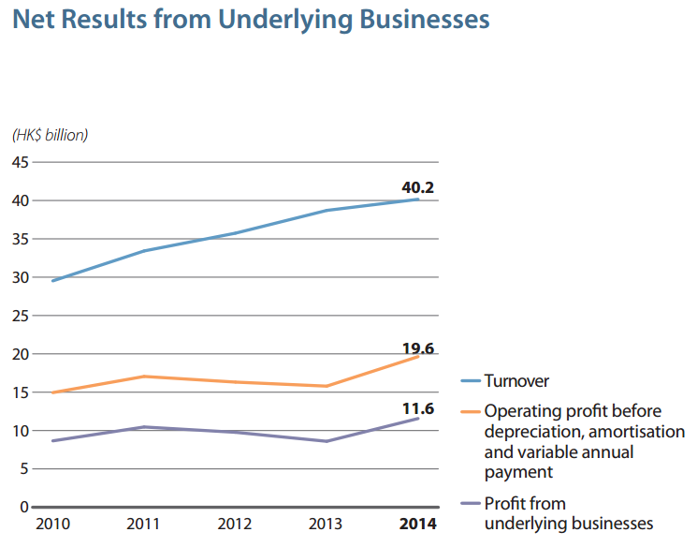

*Figure 2: Net results from underlying businesses [1]*

*Table 4* shows the breakdown revenue and expenses of each major business operations of MTR. Revenue rose steadily over the last 5 years from HK$29.5 billion to HK$40.1 billion. With the rising expenses, profit remained at similar level till 2014 where an improvement was observed (see *Figure 2*). As reflected in *Figure 1*, major contributions of profit in dollar are HK transport operations, HK station commercial business, HK property rental & management businesses, and property development.

|  |  |  |  |  |  |
| --- | --- | --- | --- | --- | --- |
|  | 2014 | 2013 | 2012 | 2011 | 2010 |
| HK Transport Operation | 43% | 44% | 46% | 46% | 46% |
| HK Station Commercial Businesses | 90% | 90% | 89% | 90% | 90% |
| HK Property Rental and Management Businesses | 82% | 82% | 82% | 81% | 78% |
| Mainland of China and International Subsidiaries | 6% | 6% | 5% | 4% | 3% |
| Other Businesses | 9% | 8% | 4% | 9% | 19% |
| HK Property Development | N/A | N/A | N/A | N/A | N/A |

*Table 5: Rough estimation of operating margin for each major business section before depreciation and taxes*

$$Operating Margin \left(Estimated\right)= \frac{Earnings before Depreciation \& Taxes}{Revenue of Particular Section}$$

The table above shows the rough estimation of profitability of each major business section of MTR. Due to the lack of breakdown details, no estimation can be figured out for the HK property development. Both the HK station commercial businesses and HK property rental & management businesses give a high and stable profitability of around 80 - 90% as they make use of the space / facilities in the existing railway station and other assets to generate income while the associated costs are small. The HK transport operation also gives good profitability of above 40% with a mild drop in last 2 years caused by the rising expenses. With the abundant operating profit, 4% rise from 2013, MTRC does not have any immediate pressure to rise fare price. But management may consider having tighter control over expenses or planning for future fare rise to cover them using the fare adjustment mechanism if the dropping trend of operation margin persists. For Mainland of China & international subsidiaries and other businesses, their profitability is relative low, under 10% on average, compared with the rest. When appreciation, amortisation & variable annual payment is taken into account, their profitability may be even lower but still better than the interest rate offered by the bank when the business fund is put into term deposit. Nevertheless, improvement was observed in recent years for the Mainland of China and international subsidiaries. A thing that is worth attention is the significant drop in profitability for other businesses since 2011. Investigation may be necessary to understand the reason behind to come up with remedy solutions. Further details on the performance of each core business and comparison analysis will be discussed in later sections.

|  |  |  |  |  |  |
| --- | --- | --- | --- | --- | --- |
|  | 2014 | 2013 | 2012 | 2011 | 2010 |
| Return on Total Assets | 6.46% | 5.18% | 5.91% | 6.67% | 6.49% |
| Return on Equity | 9.66% | 8.65% | 9.46% | 11.65% | 10.38% |

*Table 6: Return of the overall business*

$$Return on Total Assets= \frac{Earnings before Interests \& Taxes}{Total Assets}$$

$$Return on Equity= \frac{Net Income}{Shareholder's Equity}$$

*Table 6* shows the return of the overall business over the last 5 years. The return on total assets stays in the level of 5.18 - 6.67% while the return on equity fluctuates in the range of 8.65 - 11.65%. There was a mild drop in 2012 - 2013 for both return indicators but picking up in 2014. Considering the risk of the business, this level of return is considered as reasonable when compared with the average performance of other major businesses listed in the Heng Seng Index 50 []. Some example figures are listed in the table below.

|  |  |  |
| --- | --- | --- |
|  | Return on Total Assets (%) | Return on Equity (%) |
| CLP Power | 4.69 | 12.80 |
| Henderson Land | 5.83 | 6.96 |
| China Merchants Group | 4.42 | 6.71 |
| Sinopec Corporation | 3.20 | 7.84 |

*Table 7: Return of a few major companies listed in HSI in 2014* []

**5.1.4 Consolidated Income Statement**

| for the year ended 31 December in HK$ million | 2014 | 2013 | 2012 | 2011 | 2010 |
| --- | --- | --- | --- | --- | --- |
| **Profit for the year** | 15,797 | 13,208 | 13,671 | 15,688 | 12,172 |
| **Other comprehensive income for the year (after taxation and reclassification adjustments):** |  |  |  |  |  |
| Items that will not be reclassified to profit or loss: |  |  |  |  |  |
| – Surplus on revaluation of self-occupied land and buildings | 116 | 298 | 339 | 471 | 285 |
| – Re-measurement of net liability of defined benefit plans | -370 | 686 | 0 | 0 | 0 |
|  | -254 | 984 | 339 | 471 | 285 |
| Items that may be reclassified subsequently to profit or loss: |  |  |  |  |  |
| – Exchange differences on translation of: |  |  |  |  |  |
| – financial statements of overseas subsidiaries and associates | -95 | 109 | 72 | 146 | 141 |
| – non-controlling interests | -26 | -35 | 3 | -1 | 16 |
| – Cash flow hedges: net movement in hedging reserve | 37 | -61 | 23 | -12 | -26 |
|  | -84 | 13 | 98 | 133 | 131 |
|  | -338 | 997 | 437 | 604 | 416 |
| **Total comprehensive income for the year** | 15,459 | 14,205 | 14,108 | 16,292 | 12,588 |
|  |  |  |  |  |  |
| **Attributable to:** |  |  |  |  |  |
| – Equity shareholders of the Company | 15,294 | 14,057 | 13,966 | 16,161 | 12,459 |
| – Non-controlling interests | 165 | 148 | 142 | 131 | 129 |
| **Total comprehensive income for the year** | 15,459 | 14,205 | 14,108 | 16,292 | 12,588 |

*Table 8: Consolidated comprehensive income statement for the last 5 years [1]*

Figures in the consolidated comprehensive income statement correspond to the profit & loss statement with no worrying entries observed. Management of MTR may keep an eye on items like re-measurement of net liability of defined benefit plans, exchange rate difference of overseas subsidiaries to prevent any unexpected financial losses.

**5.1.5 Retained Earnings Statement**

|  |  |  |  |  |  |
| --- | --- | --- | --- | --- | --- |
| for the year ended 31 December in HK$ million | 2014 | 2013 | 2012 | 2011 | 2010 |
| **Balance as at 1 January (start of the current financial year)** | 104,965 | 95,832 | 85,506 | 71,781 | 62,705 |
| Profit for the current year | 15,606 | 13,025 | 13,375 | 15,556 | 12,059 |
| Other comprehensive income for the current year | -370 | 686 | 1,344 | 2,208 | 0 |
| Total comprehensive income for the current year | 15,236 | 13,711 | 14,719 | 17,764 | 12,059 |
| Final dividend of previous year | -3,886 | -3,130 | -2,951 | -2,598 | -2,177 |
| Interim dividend of the current year | -1,455 | -1,450 | -1,447 | -1,446 | -807 |
| Employee share options forfeited | 3 | 2 | 5 | 5 | 1 |
| **Balance as at 31 December (end of the current financial year)** | 114,863 | 104,965 | 95,832 | 85,506 | 71,781 |

*Table 9: Retained earnings for the last 5 years [1]*

As seen from the table above, with a stable level of profit, the retained earnings of MTR in 2014 accumulated to $114,863 million which was a positive trend.

**5.1.6 Consolidated Cash Flow Statement**

| for the year ended 31 December in HK$ million | 2014 | 2013 | 2012 | 2011 | 2010 |
| --- | --- | --- | --- | --- | --- |
| **Cash flows from operating activities** |  |  |  |  |  |
| Cash generated from operations | 16,519 | 15,446 | 14,701 | 12,489 | 11,920 |
| Receipt of government subsidy for Shenzhen Metro Longhua Line operation | 652 | 661 | 637 | 638 | N/A |
| Current tax paid |  |  |  |  |  |
| – Hong Kong Profits Tax paid | -954 | -1,183 | -1,699 | -1,949 | -1,007 |
| – Mainland of China and overseas tax paid | -173 | -160 | -100 | -154 | -4 |
| **Net cash generated from operating activities** | 16,044 | 14,764 | 13,539 | 11,024 | 10,909 |
|  |  |  |  |  |  |
| **Cash flows from investing activities** |  |  |  |  |  |
| Capital expenditure |  |  |  |  |  |
| – Purchase of assets for Hong Kong transport and related operations | -2,889 | -2,790 | -2,327 | -2,102 | -1,953 |
| – Shenzhen Metro Longhua Line Project and related operations | -471 | -577 | -852 | -1,385 | -1,846 |
| – Island Line Extension Project | -2,760 | -2,537 | -2,897 | -3,111 | -3,218 |
| – South Island Line (East) Project | -2,611 | -3,283 | -2,480 | -1,467 | -347 |
| – Kwun Tong Line Extension Project | -969 | -1,029 | -976 | -450 | -190 |
| – Shenzhen Longhua Line Depot Property Development | -681 | -2,146 | N/A | N/A | N/A |
| – Hong Kong Property Development | -410 | -550 | -1,440 | -1,075 | -4,444 |
| – Investment property projects and fitting out work | -1,497 | -366 | -104 | -255 | -173 |
| – Other capital projects | -71 | -77 | -49 | -198 | -165 |
| Net cash (payment)/receipt in respect of entrustment works of Shatin to Central Link | N/A | N/A | -148 | 170 | 84 |
| Fixed annual payment | -750 | -750 | -750 | -750 | -750 |
| Variable annual payment | -1,247 | -883 | -647 | -45 | N/A |
| Receipts in respect of Hong Kong property development | 9,176 | 3,937 | 5,677 | 1,593 | 5,249 |
| Receipt of loan repayment from a property developer | N/A | N/A | N/A | 2,000 | N/A |
| Receipt of government grant for West Island Line Project | N/A | N/A | N/A | N/A | 12,252 |
| Decrease / (Increase) in bank deposits with more than three months to maturity when placed or pledged | 6,607 | 3,463 | -831 | -3,063 | -9,610 |
| Purchase of investments in securities | -177 | -192 | -260 | -160 | -3,844 |
| Proceeds from sale or redemption of investments in securities | 122 | 109 | 2,846 | 1,094 | 159 |
| Proceeds from disposal of fixed assets | 10 | 4 | 8 | 5 | 7 |
| Investment in an associate | -294 | -1,111 | -2,734 | N/A | N/A |
| Proceeds from disposal of an associate | N/A | 62 | N/A | N/A | N/A |
| Receipt of loan repayment from an associate | N/A | 24 | 24 | 29 | N/A |
| Settlement of loan repayment to an associate | N/A | N/A | N/A | -29 | N/A |
| Dividends received from and non-controlled subsidiaries and associates | 43 | 197 | 465 | 144 | 75 |
| **Net cash generated from/(used in) investing activities** | 1,131 | -8,495 | -7,475 | -9,055 | -8,714 |
|  |  |  |  |  |  |
| **Cash flows from financing activities** |  |  |  |  |  |
| Proceeds from shares issued under share option schemes | 377 | 136 | 186 | 34 | 63 |
| Drawdown of loans | 11,171 | 2,229 | 808 | 1,392 | 8,153 |
| Proceeds from issuance of capital market instruments | 543 | 3,248 | 5,998 | 2,198 | N/A |
| Repayment of loans | -10,205 | -918 | -6,319 | -1,111 | -5,390 |
| Repayment of capital market instruments | -5,158 | -3,336 | -102 | -500 | -5,778 |
| Interest paid | -791 | -967 | -727 | -603 | -861 |
| Interest received | 218 | 253 | 342 | 194 | 123 |
| Finance charges paid | -29 | -38 | -53 | -12 | -19 |
| Dividends paid to equity shareholders of the Company | -4,944 | -4,580 | -4,398 | -3,754 | -1,814 |
| Dividends paid to holders of non-controlling interests | -153 | -192 | -121 | -88 | -58 |
| **Net cash used in financing activities** | -8,971 | -4,165 | -4,386 | -2,250 | -5,581 |
| Net increase in cash and cash equivalents | 8,204 | 2,104 | 1,678 | -281 | -3,386 |
| Cash and cash equivalents at 1 January | 7,209 | 5,105 | 3,427 | 3,708 | 7,094 |
| Cash and cash equivalents at 31 December | 15,413 | 7,209 | 5,105 | 3,427 | 3,708 |

*Table 10: Consolidated cash flow statement for the last 5 years [1]*

The consolidated cash flow statement for the last 5 years is shown in the table above. The major sources of cash are operating activities and receipts in respect of HK property development. The major uses of cash are repayment of loans / capital market instruments and extension projects. Cash reserve in the business has been improved since 2012. This is due to the recent realisation of return from HK property development and less amount of cash being spent on property development & security purchase in recent years. Overall, the statement shows a healthy situation in cash flow.

**5.2 Hong Kong Transport Operations**

**5.2.1 Market Share & Patronage**

The HK transport operations business is a major profit contributor of MTRC. With the wide coverage of network, continuous expansion and increasing amount of population / travelers, the company maintains the largest market share in transportation. It also results in a sustainable growth of patronage and fare revenue.

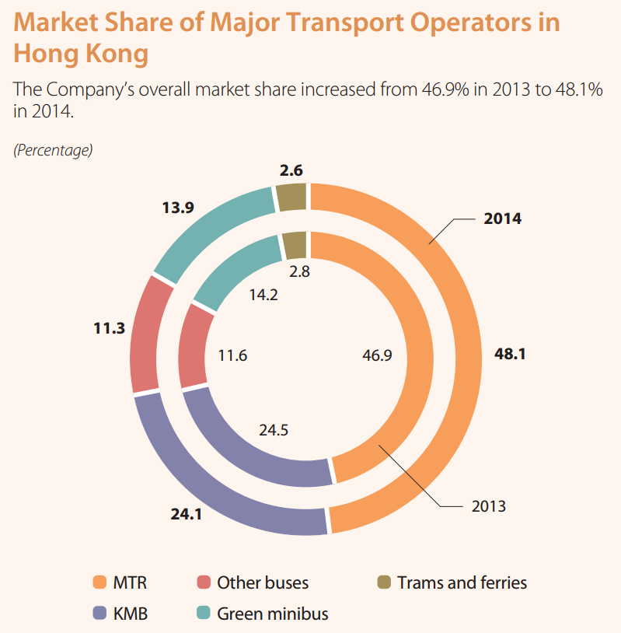

*Figure 3: Market share of major transport operators in HK in 2014*

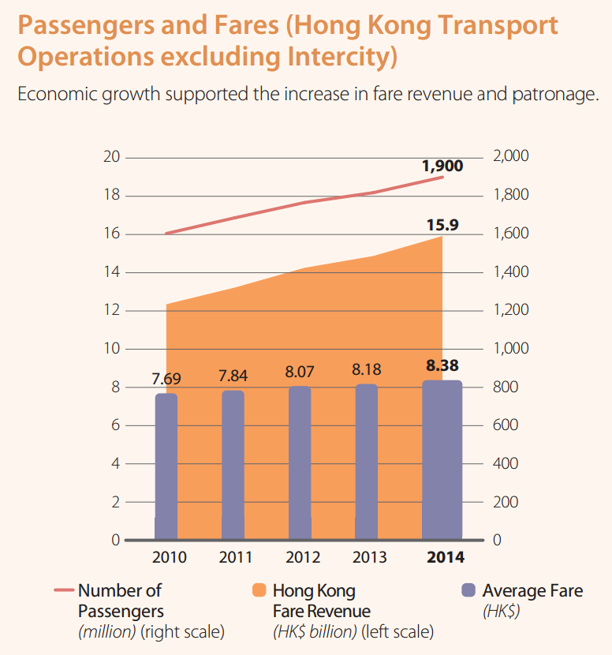

*Figure 4: The growth of passenger number and fare amount of MTRC from 2010 to 2014*

**5.2.2 Comparison with Similar Business Overseas**

To further study the financial performance of it in comparison with other companies of similar nature, railway operators of high utilization in various cities are looked at. For places like Sydney and Beijing, their railway operators are not profit making and most of the operation deficits are subsidized by government according to their financial reports. Their railway infrastructures are built and maintained to provide a transportation option for local citizens to ease up the traffic jam on roads.

Singapore, which has a closer economy culture & living environment as HK, is particularly selected for comparison. Similar to MTRC, Singapore’s railway operator, SMRT Corporation Ltd, is the largest transport operation in the country and has wide railway network coverage. It has businesses in station commercial and overseas subsidiaries but does not have any business in property rental / development. The following tables sum up the key analysis figures for the 2 companies.

|  |  |  |  |  |  |  |
| --- | --- | --- | --- | --- | --- | --- |
|  | **2014** | **2013** | **2012** | **2011** | **2010** | **Average** |
| Operating Margin | 22.0% | 24.8% | 28.4% | 32.5% | 35.9% | **28.7%** |
| Return on Total Asset | 2.90% | 4.20% | 7.10% | 10.10% | 10.60% | **6.98%** |
| Return on Equity | 7.90% | 10.70% | 15.10% | 20.50% | 21.80% | **15.20%** |
| Debt Ratio | 0.63 | 0.65 | 0.55 | 0.50 | 0.51 | **0.57** |
| Current Ratio | 0.57 | 1.09 | 0.52 | 1.13 | 1.36 | **0.93** |
| Interest Cover | 24.5 | 39.4 | 48.6 | 44.2 | 40.6 | **39.5** |

*Table 11: Summary of financial analysis of SMRT, Singapore [3]*

|  |  |  |  |  |  |  |
| --- | --- | --- | --- | --- | --- | --- |
|  | **2014** | **2013** | **2012** | **2011** | **2010** | **Average** |
| Operating Margin | 38.4% | 37.2% | 36.1% | 36.3% | 37.0% | **37.0%** |
| Return on Total Asset | 6.46% | 5.18% | 5.91% | 6.67% | 6.49% | **6.1%** |
| Return on Equity | 9.66% | 8.65% | 9.46% | 11.65% | 10.38% | **10.0%** |
| Debt Ratio | 0.28 | 0.29 | 0.3 | 0.32 | 0.35 | **0.31** |
| Current Ratio | 1.33 | 1.54 | 1.69 | 1.54 | 1.45 | **1.51** |
| Interest Cover | 15.2 | 11.5 | 13 | 14.5 | 10.5 | **12.94** |

*Table 12: Summary of financial analysis of MTRC, Hong Kong*

SMRT's operating margin was in similar value, 35.9%, as MTRC's in 2010 but it decreased dramatically to 22% in 2014. SMRT's return on total asset & return on equity used to be almost twice better than MTRC's in 2010 but both figures dropped to record low of 2.9% and 7.9% respectively in 2014, which are worse than MTRC's 5-year average values. For the debt ratio, SMRT's is almost twice the value of MTRC's and has an increasing trend in debt while MTRC shows an opposite trend. Current ratio of below 1 in years 2014 & 2012 shows that SMRT cannot always maintain adequate amount of current asset to meet its current liability and has certain amount of liquidity risk. Nevertheless, SMRT can still maintain a high interest cover but a decreasing trend is observed again.

Obviously, MTRC is able to run a better business than SMRT. Further investigation may need to be carried out to understand the bad performance of SMRT in recent years. By developing property business along the railway network, it appears that it helps MTRC to guarantee a fixed amount of passenger flow. It gives more stable returns and higher operating margin year from year compared to SMRT.

**List of References**

1. MTR Website: http://www.MTRom.hk/en/corporate/investor/2014frpt.html
2. AA Stocks Website: http://www.aastocks.com/tc/stocks/market/index/hk-index-con.aspx?index=HSI&t=4&hk=0&s=1&o=1